Model Lesson Plan
Marvin Todd
David Crockett MS/Travis HS

Course:  U.S. History | Title of Unit:  Post World War II America | Title of Lesson:  Domino Theory and the Vietnam War
Grade Level:  11 | Title of Unit:  Post World War II America | Time Frame:  3 – 55 minute lessons

Description – This lesson covers the events and political issues leading to the Vietnam War. Areas covered are the realpolitik of the post-World War II world. The influence of the Cold War on what happened in Southeast Asia, alignment of American allies in the area, the effects of Containment and the Domino Theory on developments in French Indo-China. The lesson covers American political decisions taken due to the French defeat at Dien Bien Phu and the resultant Geneva Accords in 1954. Particular emphasis covers American actions taken after the French defeat to create a South Vietnam. The lesson then proceeds to focus on the steps that the Eisenhower, Kennedy and Johnson administrations took to ‘save’ Vietnam from the Communist sphere.

TEKS Objectives - (8) History: The student understands the impact of significant national and international decisions and conflicts in the Cold War on the United States. The student is expected to:

(D) explain reasons and outcomes for U. S. involvement in foreign countries and their relationship to the Domino Theory, including the Vietnam War;
(E) analyze the major issues and events of the Vietnam War such as the Tet Offensive, the escalation of forces, Vietnamization, and the fall of Saigon; and
(F) describe the responses to the Vietnam War such as the draft, the 26th amendment, the role of media, the credibility gap, the silent majority, and the anti-war movement.

Teacher to Teacher Notes –
- The base for this lesson is the power point attached. It moves quickly through the time frame covering the TEKS listed above. Note that pictures are references in the notes section of the power point.
- Primary and secondary materials are noted on each slide of the power point and are attached for your use. Each is listed below in sequence of use.
- Start the lesson with an overview of the globe, then moving to the map identifying the area known in 1946 as French Indo-China.
- Film clips – I have listed three for your use, please determine how many or few you wish to use in your classroom.
- Pictures cover a wide range of events during the period 1945-75; emphasis must be placed on the effects of the Vietnam War on America as it corresponded to the many changes going on within our culture in the 1960’s. The War is not occurring in a vacuum…a lot is happening in the United States in the 1960’s (see the last slide).
- Be sure to use the DBQ on the Vietnam War.

Materials needed:  PowerPoint attached.  George Keenan’s Long Telegram  NSC68 -  Geneva Agreement 1954  Tonkin Gulf Resolution -  SDS Manifesto  Film Clips – see Websites listed.  LBJ speeches  Tapes of Kennedy and LBJ in the White House.  Tape – ‘The Fog of War’ by Errol Morris  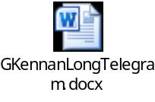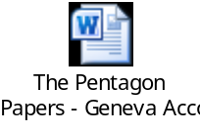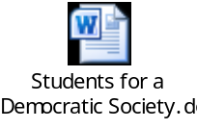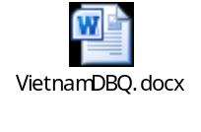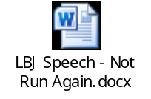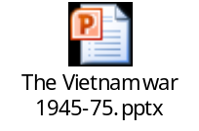 | Websites used:  Collection of US government documents:  http://www.ourdocuments.gov/doc.php?flash=true&doc=98  http://www.history.com/topics/vietnam-war/videos#tet-offensive  http://www.history.com/topics/vietnam-war/videos#joe-galloway  http://www.history.com/topics/vietnam-war/videos#search-and-destroy  http://www.history.com/topics/lyndon-b-johnson/videos#johnson-says-he-wont-run

Procedures/Activities
Engage – Ask students what they would do if one of their best friends or allies asks them for help when it looked like they would lose a very important possession if they did not get some help real quick. Would they question all the ramifications involved or would they help?

Explain – Discuss French Indo-China and the importance it represented to France, our ally in Europe when World War II ended, and a country we wanted to keep from coming under communist control. How this help involved the overall policy of the United States under the Truman Doctrine, NSC68, and our concept of Containment of Communism. These steps led us into our involvement in Vietnam.

Explore – How public and foreign policy are many times affected by actions all over the world, and may or may not be in the best interest of the United States in the long run. Begin with the location of French Indo-China and the territory involved in the area (especially Communist China) and the political pressures this brought upon American foreign policy leading to the Vietnam War.

Assessment(s)
Evaluate-
- As an informal assessment, use the mid-point question in the power point. (What would the student have done at the point of escalation in 1965, how would they have handled the issue.)
- As a formal summative assessment, students will use a free-response item from the 2008 AP Test. (see form attached)

Instructional Alternatives
Extend – The National Archives website has a primary source lesson. Teaching with Documents: The Vietnam War in Photographs. It has wonderful professional pictures and worksheets covering the Vietnam era.

Interdisciplinary Connections
The map of the Indo-China area provides an opportunity to review geography and how it influences decisions at the highest levels. Direct students to indicate on the map or globe the territory in question and the other countries involved in the issues discussed. Why was the United States reluctant to bomb the bridges over the Red River leading into China?

