Model Lesson Plan
Melody McClean
Oakland Elementary
Course:  Social Studies/ELA | Title of Unit:  Portraits of Noteworthy Americans | Title of Lesson:  Ordinary Americans Who Did the Most Extraordinary Things!
Grade Level:  5th | Title of Unit:  Portraits of Noteworthy Americans | Time Frame:  5 sessions 30 mins. each

Description
The student will create a foldable of a noteworthy American which will look like a picture frame with the person’s picture (drawn by student) on the front and research inside.

TEKS Objectives
Any TEKS identifying the accomplishments of significant individuals can be used for this project. Specific TEKS for the time period of the grant might include:
- 5.3B identify the contributions of individuals, including James Madison, and others such as George Mason, Charles Pinckney, and Roger Sherman who helped create the U.S. Constitution
- 5.4 B identify and explain how changes resulting from the Industrial Revolution led to conflict among sections of the United States (identify significant individuals’ contributions to the Industrial Revolution)
- 5.4D identify significant events and concepts associated with U.S. territorial expansion, including…the expedition of Lewis and Clark
- 5.4F explain how industry and the mechanization of agriculture changed the American way of life (identify significant individuals’ contributions to the mechanization of agriculture)
- 5.4G identify the challenges, opportunities, and contribution of people from various American Indian and immigrant groups
- 5.5C identify the accomplishments of individuals and groups such as Jane Addams, Susan B. Anthony……
- 5.23A identify the accomplishments of notable individuals in the fields of science and technology, including Benjamin Franklin, Eli Whitney, John Deere, Thomas Edison, Alexander Graham Bell, George Washington Carver, the Wright Brothers,…
TEKS Skills Objectives:
- 5.24A differentiate between, locate, and use valid primary and secondary sources such as computer software; interviews; biographies, oral print, and visual material; documents….
- 5.24B analyze information by sequencing, categorizing, identifying cause-and-effect relationships, comparing, contrasting, finding the main idea, summarizing, making generalizations and predictions, and drawing inferences and conclusions
- 5.24C organize and interpret information in outlines, reports, databases, and visuals, including graphs, charts, timelines, and maps
- 5.24E identify the historical context of an event
- 5.25B incorporate main and supporting ideas in verbal and written communication
- 5.25D create written and visual material such as…reports
- 5.25E use standard grammar, spelling, sentence structure, and punctuation

Teacher to Teacher Notes
I think the main thing to remember here is the finished product—how cute and informative they are. Once you’ve done this the first time and then have samples to show the students in subsequent years, it makes this activity more fun because the kids usually go all out trying to “one-up” some of the projects they saw as examples. My school happens to be in a wealthier area and the parents are really good about going all-out procuring the materials their kids need to make their project look really neat. I never let my students do any of this work at home due to the fact that many parents want to “help”, and it then becomes obvious that the parent actually completed the project, not the student. (Our school’s policy is that we don’t grade work that is done at home for that very reason.) This way, the students may bring materials and possibly even research from home, but none of the work is actually done at home. This is an assignment they may work on over the course of a week when they are finished with classroom assignments. If your school is in an economically disadvantaged area and you cannot depend on parents to send craft materials (pipe cleaners, feathers, foam letters and shapes, or anything that one would consider scrapbook-type items), consider asking local business to donate items that you think the kids could use. You might try JoAnn’s Fabric Stores, Hobby Lobby, Wal-mart, or any art shop.

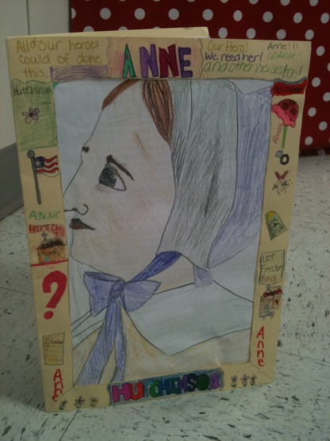
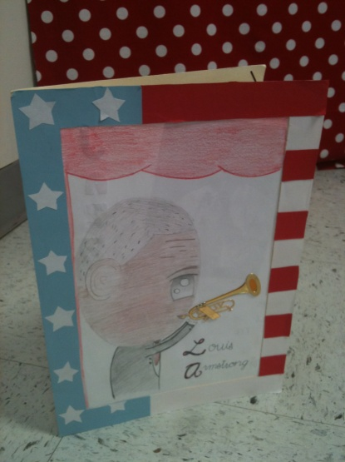
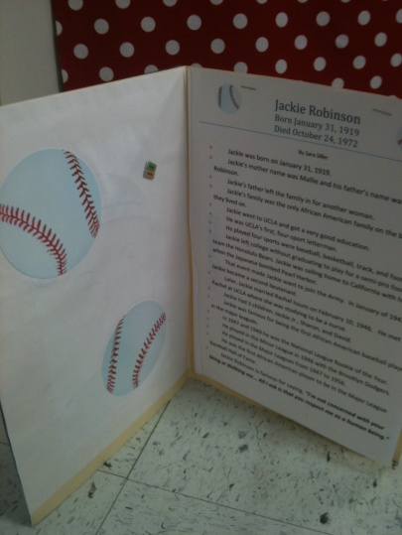
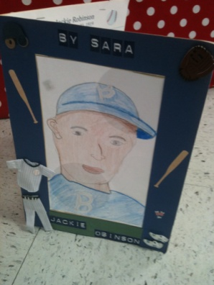

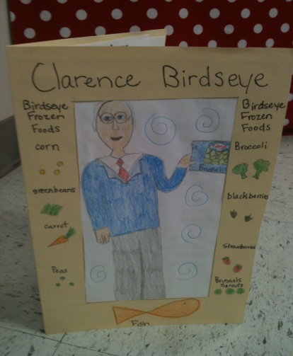
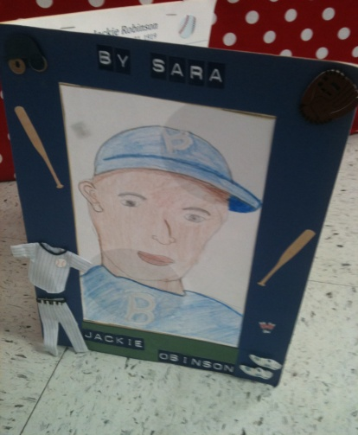
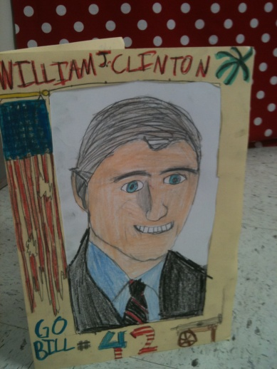

Materials needed:  - a book from the school library over the assigned noteworthy American (student choice)  - manilla folder  - items the student might wish to use to decorate his/her “picture frame” (see suggestions in teacher-to-teacher notes)  - teacher instruction sheet (attachment)  - scissors, markers, glue stick  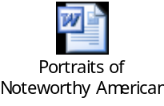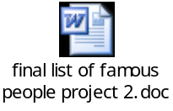 | Websites used:  Students may go online to find articles over their assigned Noteworthy American. In Fort Bend ISD we subscribe to several online data bases: GALE, World Book online, and Nettrekker. Hopefully, your district can provide these resources as well. Ask your school librarian for help finding academically sound resources.

Procedures/Activities
Engage: because this project is rather “artsy” in nature, students are usually engaged from the minute I introduce samples from previous years. You may also engage students by allowing them to choose from a list (attached) of noteworthy Americans; I have found that if they feel that they have a say in who/what they are reading and researching, the process is much more pleasant for all of us.

Explain: I usually assign this project in the spring to make an interesting product to display at our spring open house. As a result of this, when I assign this project, we have already studied some of the individuals on the list of 5th grades TEKS. Students usually choose those people first because they already know a little about the individual. Explain to students that they are basically creating a “picture frame” for their assigned noteworthy American, and when the frame is opened, the researched information will be displayed (like a book) inside. Students always ask if they can print pictures of their topic from the internet, and the first year I did this project I allowed it. In the last two years I insisted they draw the person, and the projects are infinitely better. It is amazing what some of these kids can do—and the ones who aren’t as artistically gifted always come up with the cutest pictures! So I firmly believe, and tell my students, that you do not have to be an artist for this project to end up looking fantastic!

Explore: Tell the students that you have given them a list of items to research that are probably the most important things a “normal person” should know about each individual—after all, the State of Texas deemed them important enough to include them in our TEKS. If they come across information that they deem pertinent and as important as any of the guidelines I’ve given them, go ahead and add it to their report. I always have them present their project—just a little three minute presentation telling us who their person is, why they are important in American History, and the top three most important items that they learned or found out about their individual.

Assessment(s)
Evaluate: rubric (attached)
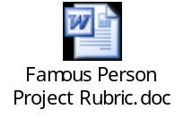

Instructional Alternatives
Extend: students may present their project to the class orally in a 3 minute presentation, highlighting the main accomplishments of their assigned American (I give them the guidelines of which information they are required to tell the class, then let them choose 2-3 interesting tidbits of information that they found unusual or “cool”.).

Interdisciplinary Connections
Technology TEKS
126.3(b) Information acquisition
(4) The student uses a variety of strategies to acquire information from electronic resources, with appropriate supervision. The student is expected to:
(B) select appropriate strategies to navigate and access information on local area networks (LANs) and wide area networks (WANs), including the Internet and intranet, for research and resource sharing.
(6) The student evaluates the acquired electronic information. The student is expected to:
(A) apply critical analysis to resolve information conflicts and validate information

